* Name**: Varun Raveendra**
* Picture: 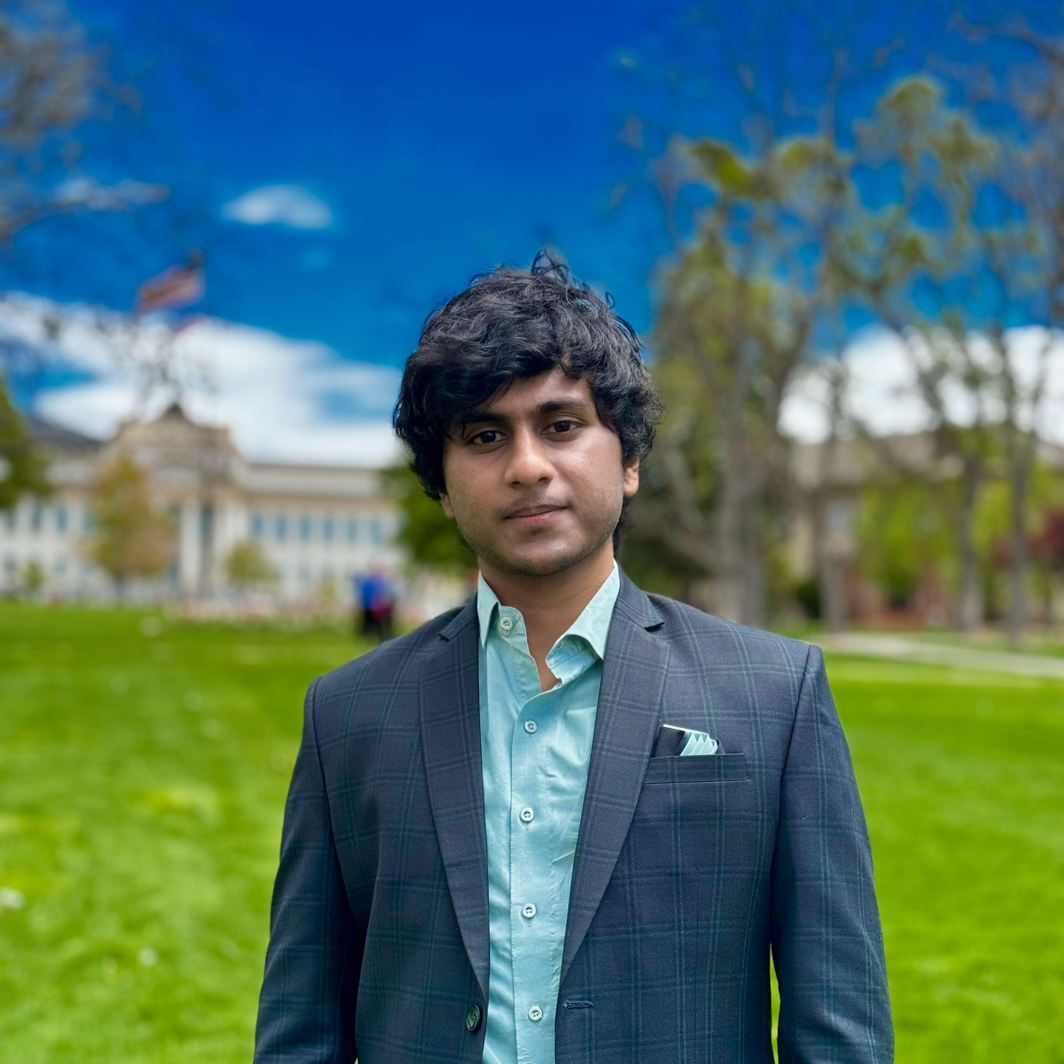
* Degreeand Department: PhD in Robotics**.**
* About**:** I am a PhD student at the University of Utah. My research interests include Reinforcement Learning with Robots, RLHF, Swarm Robots, and Multi-Agent Robots.
* Links**:**
  + Personal Website Link: www.linkedin.com/in/varun-robotics
  + Personal Github Link: https://github.com/varunraveendra